The professional voice of the UK Fire & Rescue Service

Fire Safety Measures for Semi-Permanent Tented Structures Providing Sleeping Accommodation

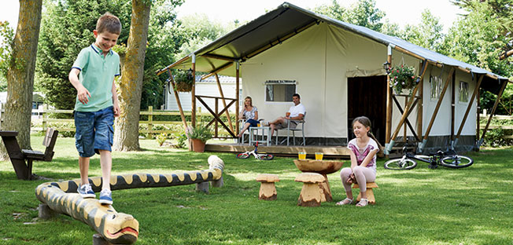

The following advice is provided for site layout(s) and spacing where ‘Safari tents’ - ‘Yurts’ - ‘Geo-domes’ - ‘Super-tents’ and similar structures are used as a semi-permanent sleeping accommodation provision. Along with additional fire safety arrangements and guidance, at sites which are licenced. This guidance also covers these types of accommodation units for festivals and the like, which are located away from the actual festival/event site and will provide a starting point for any fire risk assessment considerations.

The aim of this information is to simplify and standardise the spacing and layout requirements for existing and potential new locations for site licencing. Also to clarify provisions within the tented structures to reduce fire risk, and provide advice on the extent of fire detection and warning, because of the limited information in the public domain where no set criteria has been established.

As there are currently no recognised standards, businesses should adopt the principles of the Caravan Model Standards for their site spacing and layouts of these units. It is prudent to apply the Model Standard requirements for spacing as they are the closest established norm’ for this industry - subject to following additional criteria.

Density and spacing between units

The minimum spacing distance between units:

- For semi-permanent tented structures used for sleeping accommodation - unit(s) constructed using suitably tested and certified materials conforming to appropriate flame retardant classifications - the distance should not be less than 5 metres between the habitable parts of the units.

- For those semi-permanent sleeping accommodation units constructed with no flame retardant standard(s) (or where certification is not available) the distance (at any point) between the units should not be less than 6 metres.

- Additional porches, awnings and the like, are not permitted.

- Where the unit design has an ‘overhang/protrusion’ at roof level, the distance between any part of the roof overhang and an adjacent unit, should not be less than 3 metres – whilst still meeting the 5 or 6 meters separation between the habitable areas.

- No storage or ancillary activity such as BBQ’s should be permitted between units, and will be sited 3 meters (minimum) from any habitable area.

- Parking of private vehicles adjacent to units should be discouraged – however where vehicle(s) are parked a minimum separation distance of 3 metres from any other vehicle or the adjacent unit’s habitable area must be maintained – and vehicle(s) should not obstruct entrances or access around the units.
The site unit density should be consistent with ‘Model Standards’ including health and amenity requirements. The gross density should not exceed 60 units to the hectare, calculated on the basis of the usable area (i.e. excluding lakes, roads, communal services and other areas unsuitable for the siting of caravans or tented structures) rather than the total site area.

Fire Safety Arrangements

- Single-point battery operated smoke detection conforming to the relevant British Standard, also incorporating a suitable light providing emergency lighting upon actuation, should be fitted horizontally in the living and bedroom areas. They should be positioned in accordance with manufacturer’s specifications with consideration to minimise and manage false alarms.

- Additional smoke detection (with lighting) should be provided where ‘sleeping pods’ are attached and form part to the tented structure.

- A testing regime should be carried out by the site responsible person to check the smoke detector locations and operation before each new occupation.

- Smoke detector testing sticks or other testing equipment should be considered and utilised.

- Emergency lighting outside the units should be assessed on site specific requirements with the provision of torches where additional lighting is required.

- An emergency plan ‘SPECIFIC’ to the individual site should be available.

- Fire action notices should be available in the tents with details of how to summon emergency services and assembly point location details completed.

- Where there is only one exit – a single direction of travel - the travel distance should not exceed 6.5m.

- Travel distance from any part of the structure having more than one exit should be no more than 18m – after the first 6.5m the remainder of the route should lead in different directions to alternative exits.

- A Fire Risk Assessment (FRA) ‘SPECIFIC’ to the site and the ‘type’ of unit(s) in use should be provided.

- Emergency procedures for disabled guests should be detailed.

- Suitable fire extinguisher (risk appropriate) and fire blanket should be provided in the living area of each unit.

- All provisions within the unit(s) should be subject to regular testing.

- A logbook (suitable records of testing) should be completed and available.

- All tent materials (internal and external) that have been supplied with certification to show the fire resistance rating should be documented in the site-specific fire risk assessment(s).

- All bedding and soft furnishings should conform to the Furniture and Furnishing Regulations and should be supplied by site management.

- There will be means of raising a fire warning to other users on the site within 30 meters from any tented structure on the site.

- Tents should not be located in close proximity to trees/hedges and will maintain a 3 meter separation distance.

- There should be an electricity supply to every unit, and primary lighting provided. The use of naked flame lighting should not be permitted.

- All provided electrical appliance (cooking and heating - electric powered oil filled radiator) provisions should be subject to Portable Appliance testing (PAT).

- Any Log burners and heaters should be installed, maintained and used to the manufacturer’s instructions. They should be installed by qualified and registered engineers with carbon monoxide detectors suitably fitted. Adequate guarding should be in place and safety instructions supplied to every new occupation.

- BBQs are allowed - however they must be clear of the tented structure(s) and not within the spacing between each unit. Any provided BBQ facilities will be in accordance with the spacing requirements and should be monitored by site patrols.

- Disposable BBQs – must be placed on an external, even, non-combustible surface - the minimum separation distance of 3 metres from the adjacent unit’s habitable area must be maintained and should be monitored by site patrols.

- All guests should be made aware of the importance of extinguishing any naked flames prior to retiring upon every new occupation.

Document References
- Primary Authority Assured Advice from Devon & Somerset Fire & Rescue Service for Bourne Leisure Limited
- Caravan Sites and Control of Development Act 1960
- Caravan Sites Act 1968
- Model Standards 2008 for Caravan Sites in England
- Raising the Bar – Caravan / temporary sleeping accommodation 2014
- HM Government DCLG – Sleeping Accommodation Guide
- HM Government DCLG – Open Air Events
- HM Government DCLG – Means of Escape for Disabled People
- CFOA Briefing Note – Fire Safety Enforcement on Feather Down Farm Days 2010

Acknowledgements
Produced by Dave Powlesland MIFireE - Primary Authority & Business Safety Officer from Devon & Somerset Fire & Rescue Service, for the National Fire Chiefs Council (NFCC) through Ian Whitby – NFCC Event Safety Group Work-stream chair.
Haven Holidays who are a ‘brand’ name of Bourne Leisure Group Limited.

